Tenda O1--How to Power on my O1 and enter its setup page

Step 1: Press and push the button on the back side of your O1, remove the cover. Supply power for your O1 via your power adapter or POE injector. Then connect it with computer. Two of connection methods are shown in the pictures as below.

Power Adapter:

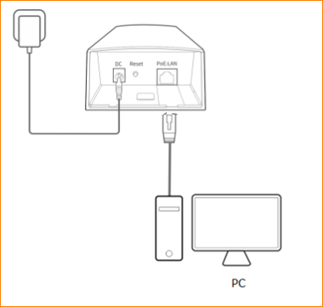

POE injector:

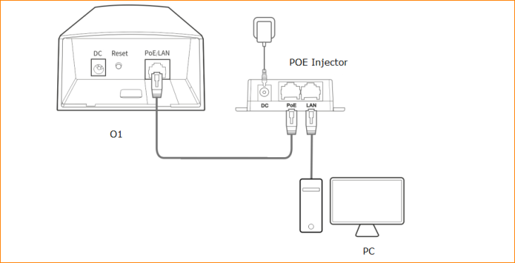

Note: After powering on, wait for it until LED of WiFi power on, that means your O1 start working.

Step 2: Configure your IPv4 as Static IP address. For more detail, refer to Tenda – How to setup static IP address for your computer.
IP address as 192.168.2.xxx (the number from 2 to 254, 20 to 254 is recommended because you need to leave some IP for the other O1 work at client mode)
subnet mask as 255.255.255.0
Default gateway as 192.168.2.1

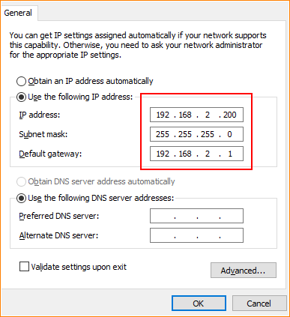

Note: If you are not configuring your CPE for the first time, the gateway would be the one you set it before, and IP address would be in the same network segment as gateway. If you forget it, just reset it and configure it as you first configure it.

Step 3: Open a browser then type “192.168.2.1” (or the gateway you had set it before) into the Address Bar, press Enter, type the account and password, tap “Login”, then you can setup your O1.

